**Reading Fluency**

**What is reading fluency?**

Once readers no longer need to decode individual sounds in words, word reading becomes automatic, freeing up mental bandwidth (amount of cognitive resources available to completing tasks) allowing readers to focus on the meaning of language, pace and the expression of their voice.

**Why is reading fluency important?**

Our brains process about 11 million bits per second (bps) of information, but less than 100 bps are

within our conscious control which means that if a reader is using their cognitive resource to decode words on the paper, there is little processing space to make sense of the text - comprehend.

**Why monitor reading fluency?**

Developing reading fluency enhances a pupil’s ability to comprehend the written word, enabling them to use reading as a vehicle to learn.

**Which text should I use to monitor fluency?**

We have texts that have been developed for use in each year group (see webpage).

Pupils working below their year group level should use the text of the year group they have been assessed to be working in e.g. a child in Y6 working at Stage 4 will read the year 4 text. Pupils who are unable to access the texts because they are still decoding individual words, should use Phonics books. The book should reflect the phase that the pupil is working within.

**How do I administer the test?**

The pupil should be given a copy of the text and asked to read it to you. At the end of the reading, highlight the appropriate columns. Add the value of the four columns together to attain the pupil’s reading fluency score.

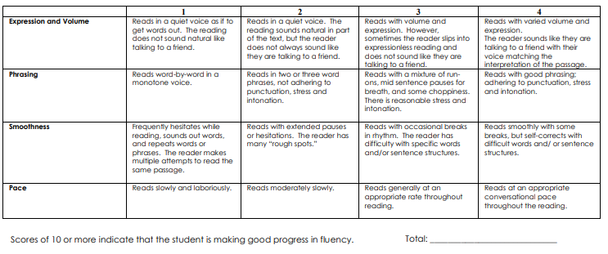

**Where do I record the results?**

Please complete a class list and keep in class.

**What should I do with the data?**

Pupils scoring 10 or more are considered to be making good progress.

Where pupils who are attaining less than 10, activities to develop reading fluency may be added into shared, guided, or whole class reading sessions.

Children who have scored in the bottom 20% of the class will need intervention.

**What activities can I use to promote reading fluency?**

Many of you will have a number of ways that you successfully promote reading fluency. Listed below are ideas which may support specific pupils/pupil groups. The list is by no means exhaustive.

**Whole class/groups**

- **Teacher-led reading:** Teacher as expert modelling fluency - encourage children to notice and remark on fluency, pace, smoothness etc.

- **Round Robin Reading:** Pupils to read aloud to the rest for the class group. Consider if pupils should/could silently read first. Also consider who is reading and why, what are you looking for?

- **Choral Reading:** All pupils, or groups of pupils reading together

- **Individual Silent Reading:** All children in class reading silently**,** independently.

**One-to-one**

- **Repeated Reading:** Pupils read a text 1:1 with a reading expert until they are able to read it error free. The reading expert provides feedback on reading errors: hesitation, omission, mispronunciation, repetition, substitution, insertion. This strategy provided pupils a model for cross checking and word processing behaviours

- **Echo Reading:** Expert reader reads a passage. Pupil listens to model then repeats. Age appropriate

discussion around: pace, smoothness, expression and volume after reading.

- **Segmenting Sentences:** Expert reader focusses on reading phrases: what emphasis was used, why has the author used it, how does it support meaning making etc.

**Alternative Approaches**

- **Read, Record:** Record pupil reading then play it back alongside dialogue. Pupils may also use this

method individually or give each other feedback on recordings.

- **From me to you:** Pupils work in pairs to read alternate sentences of a passage, or repeat the sentences of one another. They can then discuss performance: WWW/ EBI