

**Newsletter**

**15th June 2023**

**Masefield Primary School**

Believe – Achieve - Succeed



**Forgiveness Co-operation Equality Honesty Passion Resilience Gratitude Kindness**

**Message from Mr Done**

It has been a busy start to the summer 2 term with lots of events taking place. The sports day was once again a huge success – it was wonderful to showcase the talents of every child in a fun, competitive and engaging way. We have been nominated for the Pearson National Teaching Awards in 'The Award for Making a Difference - Primary School of the Year' and have achieved a certificate of excellence along with a letter from Michael Morpurgo. This week a group of head teachers visited Masefield to see our learning in action and learn about our curriculum - our children made us very proud!

**Dates for your Diary**

**Tues 20th-Wed 21st June**

Year 5 Trip to London

**Thurs 22nd June**

Year 1 Brockholes trip

**Fri 23rd June**

MacMillan Bake off

**Mon 26th – Fri 7th July**

Year 5 Swimming

**Wed 28th June**

Knowledge Day

**Fri 30th June**

Non-uniform day for hamper donations

**Year 6 Trips @MasefieldCP**



**Trip to Blackpool**

Year 6 had an incredible time at Blackpool Pleasure Beach last week. They tried all the different rides and were thoroughly worn out by the end of the day.

**Manor Adventure – Lockerbie**

On Friday, the Year 6’s left school for Scotland! Over the weekend they experienced all kinds of different and challenging activities, including paddle boarding, high ropes, crate building and the climbing wall. Here are some photos of their time at Manor Adventure, but please check out Twitter for all the photos of their action packed weekend!

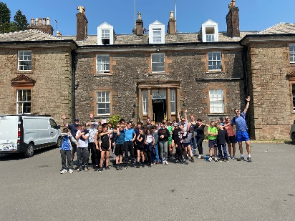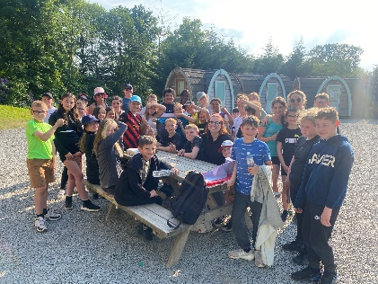



**Sports Day @MasefieldCP**

**Reception @MasefieldCP**

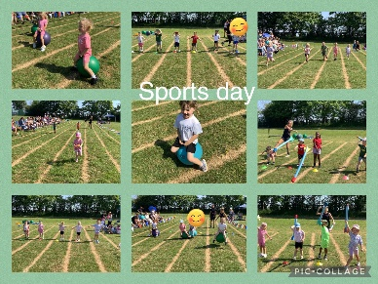

The whole school enjoyed a very sunny Sports day this week. Well done to everyone for taking part and showing fantastic sportsmanship.

Reception are being very creative at Masefield in their loose parts play area and have asked for donations of;

Pebbles, shells, curtain hooks, log slices, large keys, bottle tops and lids.

Any donations would be greatly appreciated.



Masefield Primary School

Masefield Road, Little Lever, BL3 1NG

Tel: 01204 333714

office@masefield.bolton.sch.uk

Website: www.masefield.bolton.sch.uk

Twitter: @masefieldcp

**Believe – Achieve- Succeed**



**Masefield Primary School**

Believe – Achieve - Succeed

**Newsletter**

|  |  |
| --- | --- |
| **ATTENDANCE** | |
| RECEPTION | **97.7%** |
| YEAR 1 | **98.2%** |
| YEAR 2 | **90%** |
| YEAR 3I | **92.2%** |
| YEAR 3J | **91.5%** |
| YEAR 4 | **94.7%** |
| YEAR 5 | **95.2%** |
| YEAR 6K | **90%** |
| YEAR 6R | **95.3%** |

**Attendance Update**

Our **97%** target is still achievable this year if we all work together on ensuring children are in school EVERY day and not missing any learning.

**Our attendance for the week is**

**93.9%**

**Our attendance for the year to date is**

**94.8%**

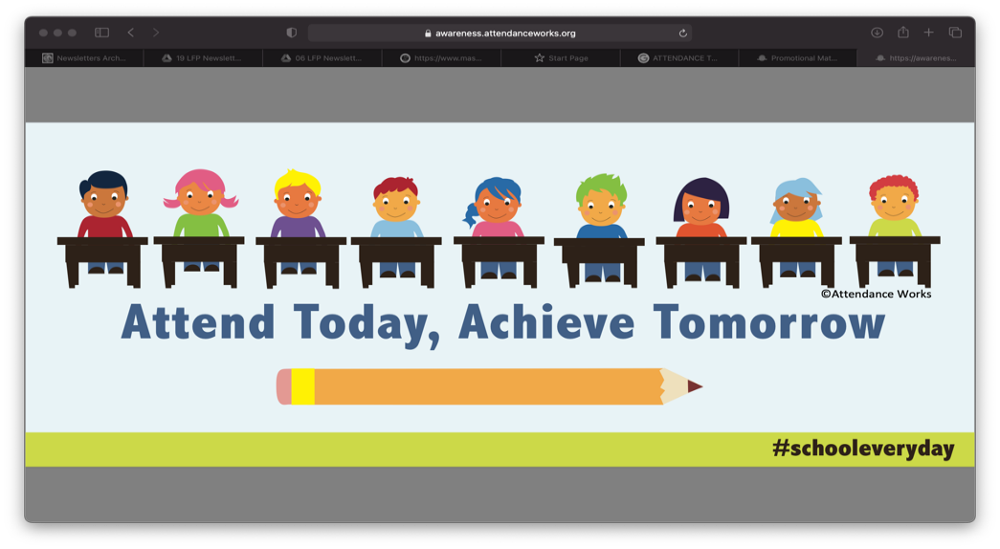

**Appointments**

We ask that medical appointments are made outside of school hours where possible.

Where it is not possible to avoid this in school time you must notify the office beforehand.

Taking your child out in school time not only disrupts the class but also impacts their learning and attendance.

If there are concerns regarding the amount of time your child is missing then proof of all future appointments will be requested.

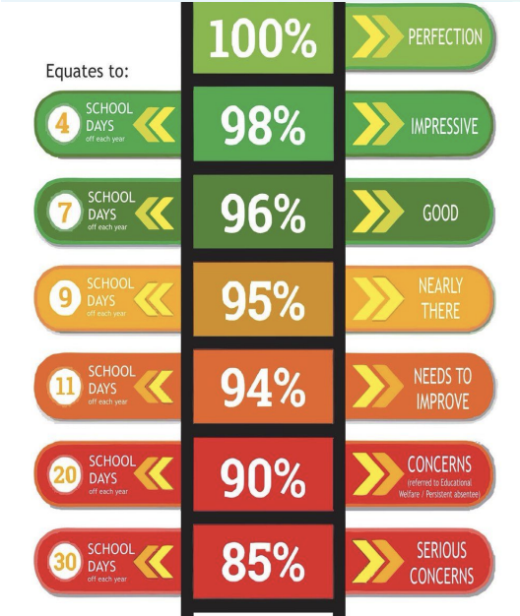



**Holidays in Term Time**  
Holidays must not be taken during term time as this has an extremely detrimental effect on your child’s education.  
The long-term cost to your child’s education of going on holiday in term time, far outweighs the short term gain of the holiday at the time. The £60 fixed penalty notice is the least of the costs; it is the impact on your child’s future educational success that presents the greatest cost. Children miss vital learning that cannot be repeated. It is widely acknowledged that mental health and personal well-being flourish when children have good routines and engage with their learning. Holidays in term time are disruptive on both counts**. I urge you to prioritise the long-term benefits of regular school attendance, over the short term impact of a holiday in term time**.



Masefield Primary School

Masefield Road, Little Lever, BL3 1NG

Tel: 01204 333714

office@masefield.bolton.sch.uk

Website: www.masefield.bolton.sch.uk

Twitter: @masefieldcp

**Believe – Achieve- Succeed**

**Celebrating Success**

|  |  |
| --- | --- |
| **Lead Learner of the Week** | |
| RECEPTION | Heidi H & Aria C |
| YEAR 1 | Toby C & Lola H |
| YEAR 2 | Jessica R & Noah C |
| YEAR 3I | Jake B & Amelia H |
| YEAR 3J | George & Francesca S |
| YEAR 4 | Byron H & Daisy S |
| YEAR 5 | Korey G & Jasper V |
| YEAR 6K | Eireann M & Maddison S |
| YEAR 6R | Jace O & Kai C |

|  |
| --- |
| **Vision & Value Award** |
| These pupils **always** show off our school vision and values. They have received Hot Chocolate & Treats with Mr Done!  Reception: Leo D  Year 1: Caleb  Year 2: Ava G  Year 3I: Lucy  Year 3J: Jacob  Year 4: Ronnie  Year 5: Marcus M  Year 6K: Gracie J  Year 6R: Daniel K |

Each week we celebrate success in Good New Assembly. Don’t forget to bring in your achievements to share!

|  |
| --- |
| **Readers of the Week** |
| Each week we award children in each class for **REMARKABLE READING.** The following children have won a book to keep **FOREVER!**  Reception: Layla W  Year 1: Isla J  Year 2: Clara Rose P  Year 3J: Georgia G  Year 3I: Imogen J  Year 4: Dylan C  Year 5: Poppy B  Year 6K: Amina M  Year 6R: Kai C |



Well done to Niamh, who raised an incredible £315 completing the May Day Mile Challenge for the RNLI!

**TT Rockstars**

Each week 3 children from each class in Year 2 and above receive an award for ‘the biggest increase in coins’ on TT Rockstars. Knowing your times tables off by heart so important – keep practising at home to win this award and certificate!

Masefield Primary School

Masefield Road, Little Lever, BL3 1NG

Tel: 01204 333714

office@masefield.bolton.sch.uk

Website: www.masefield.bolton.sch.uk

Twitter: @masefieldcp

**Believe – Achieve- Succeed**

**Masefield Primary School**

Believe – Achieve - Succeed



**Newsletter**



**Online Safety Tip**

**Safeguarding Tip**



Misogyny

This week our safeguarding focus is on online

misogyny. This is the abuse or hatred of women

on the internet. This can happen offline too,

however the anonymity of the Internet gives

individuals and communities the opportunity to

form hateful beliefs around women. Influencers

can use their platforms to spread hate, both online

and offline. Misogynistic ideas and language can

impact all children and might convince some girls

that they are inferior to boys and also influence

boys into not showing their real feelings. These

ideas and language used must be challenged in

the moment, it’s important that children

understand that these views are unacceptable.

For more information please visit:

https://www.internetmatters.org/issues/online-hat

/what-is-misogyny/

Welcome to our ‘Online Safety Tip Of The Week’. On each newsletter, we will provide you with some useful hints, tips, guides and fact sheets from the National Online Safety (NOS) website that you as parents and carers will be able to use to help keep your child safe whilst online.

This week's free online safety guide focuses on [Apex](https://www.holyredeemerschoolpershore.org/wp-content/uploads/2020/02/NOS-Apex-Legends.jpg)

[Legends](https://www.holyredeemerschoolpershore.org/wp-content/uploads/2020/02/NOS-Apex-Legends.jpg). The multiplayer battle royale video game,

which is free to play, is a game consisting of twenty

three-man squads (groups of players) who are dropped onto an island from a dropship and compete to be the last team standing. Each player on the squad gets to choose a ‘Legend’ to play with; one of eight unique characters with a specialised skill set in either ‘Offense’, ‘Defense’, Support’ or ‘Recon’. The game is currently available on PC, Playstation and Xbox and carries a 16

rating in the United Kingdom.

Masefield Primary School

Masefield Road, Little Lever, BL3 1NG

Tel: 01204 333714

office@masefield.bolton.sch.uk

Website: www.masefield.bolton.sch.uk

Twitter: @masefieldcp

**Believe – Achieve- Succeed**

**Supporting your Child**

**Sustainability Top Tip**

Nature Walks

A great way to teach kids about sustainability is by taking them on a nature walk or hike. You don't have to go far to find a beautiful place where you can take them. Your local park probably has more wildlife than you realise.

During the walk, take time to talk to them about the

plants around them and the animals that live there.

Ask them questions about the environment and what they see around them. These conversations will allow them to develop their own opinions and ideas about sustainability.

**Learning to Read – Our Phonics Scheme**

Each week we will share a video to support your understanding of our phonics scheme. Today’s video is **‘How to say the sounds’**

<https://schools.ruthmiskin.com/training/view/hnVkD0yJ/dARNl6pX>

**Reading at Home**

*‘If you cannot read, you cannot learn. If your child cannot read, their progress in all other subjects will be curtailed. There is no such thing as reading too much!’*

**Maths**

White Rose Maths have FREE downloadable booklets for each year group block. You can download them here: <https://whiterosemaths.com/parent-resources>

**All of our parent workshops are available to watch on the school website**





Masefield Primary School

Masefield Road, Little Lever, BL3 1NG

Tel: 01204 333714

office@masefield.bolton.sch.uk

Website: www.masefield.bolton.sch.uk

Twitter: @masefieldcp

**Believe – Achieve- Succeed**



**Chatty Words**

Chatty Learning provides services and tools to help get children talking, reading and learning.

Chatty Toolbox software includes Chatty Nouns and Chatty Verbs which make the perfect early intervention tool to close the vocabulary gap for children who are struggling. This is also a perfect companion to Phonics as it targets comprehension and word understanding.

The toolbox provides a parent account for you to use at home with your child – the log in details are below.

**Username**: [parent@masefield.co.uk](mailto:parent@redlane.co.uk)

**Password**: masefield1

**Please follow the help guides on the next two pages to access these new resources**



