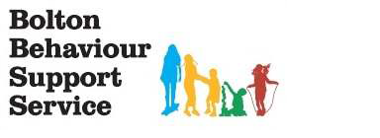
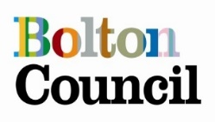

Triple P Parenting Program


Do you have parents who tell you they cannot take anymore?
They are NOT alone!!!
Triple P looks at ways we can manage some of children’s common behaviour problems and how parents can promote and support their development.
Small changes can make big differences!

The programme aims are to:
- Focus on using positive re-enforcement
- Offer strategies on managing behaviour
- Give a number of different strategies for parents to be able to use practically
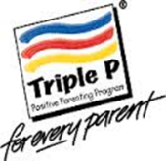

Bolton Behaviour Support Team will be running a
Triple P courses in school
for parents/carers looking for tips and support
in managing their child(ren)’s behaviour.

Masefield Primary School, Little Lever, BL3 1NG
Starts Monday 16th January and runs weekly for 4 weeks.
3.45pm-5.15pm
Contact school to confirm your place.
*Childcare available through afterschool club
Contact school/behavioursupportservice@bolton.gov.uk
or on 01204 338133 for further information

