Monday 2nd November 2020

LO: developing inference strategies.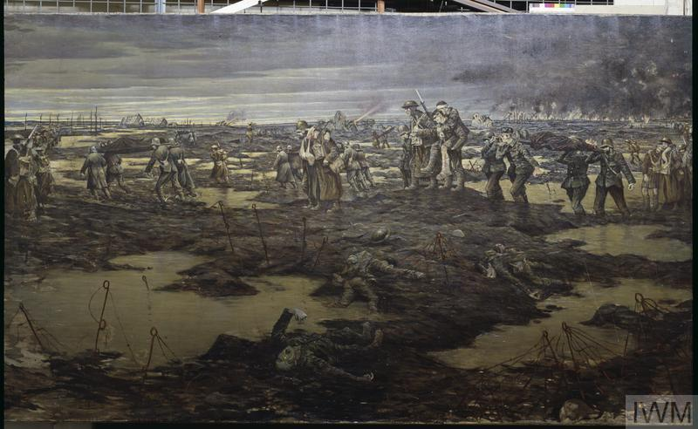

|  |  |  |
| --- | --- | --- |
| What can I see? | What would I want to ask/I wonder… | What can I infer? |
|  |  |  |