Researching Viking Life

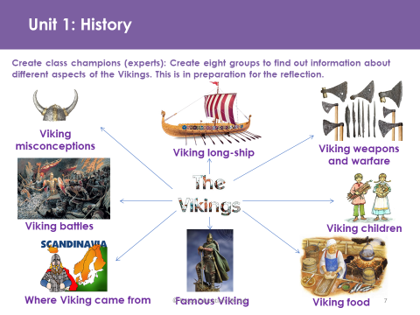

After completing your timeline of the Vikings, you are going to research what life was like as a Viking. Within your pack, you have two mind map sheets that are divided into four sections each, covering the eight sections of Viking life displayed above. Using both your own research and using the materials supplied make notes on each of the eight sections. You should have between 5 and 10 bullet points per section. Towards the end of the half term, we will be writing a non-chronological report documenting Viking life. This piece of writing will be used for assessment purposes. Therefore, it is essential that you complete this research to the best of your ability. The more detailed information you have, the more thorough your piece of writing will be. We will be adding to this document as we continue with our learning on the Vikings back at school and will be completing other pieces of work pertaining to the Vikings, which will also contribute to our knowledge of the Vikings before completing our writing. Therefore, it is vital that you complete this task, together with the timeline, so that we can use these activities subsequently within the classroom. Your notes should be written in pen and presented in your best handwriting. In order to make the most of the resources (both your own online and those provided) use our techniques from guided reading to help you process the information:

* Highlight key words in the text relating to the eight areas;
* Circle any words you do not understand and look them up in a dictionary;
* Number each paragraph;
* Summarise each paragraph.

Using this strategy will help you to identify the correct information for each section. DO NOT copy information from the Internet or the resources provided. Write it in your own words and only include information you understand and can explain to someone else in the class. I will be questioning you! This task should take between 2 – 3 hours to complete.

