06/11/2020

LO: simplifying fractions.

Yellow Task – Section A; Orange Task – Section B; Red Task – Section C

Section A

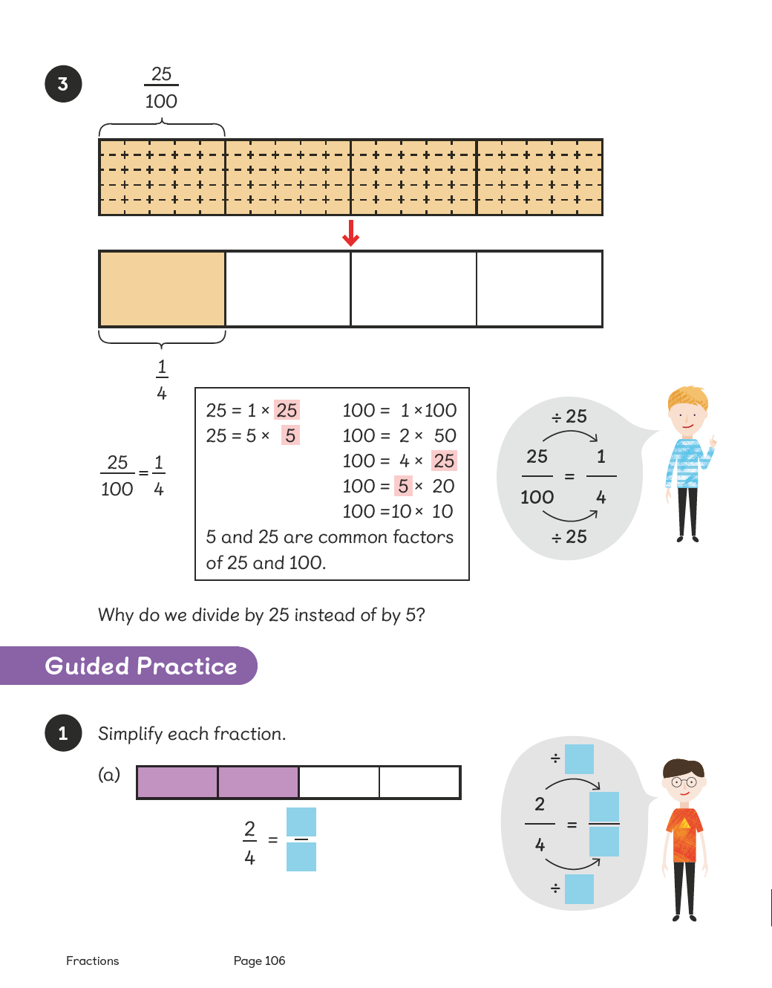

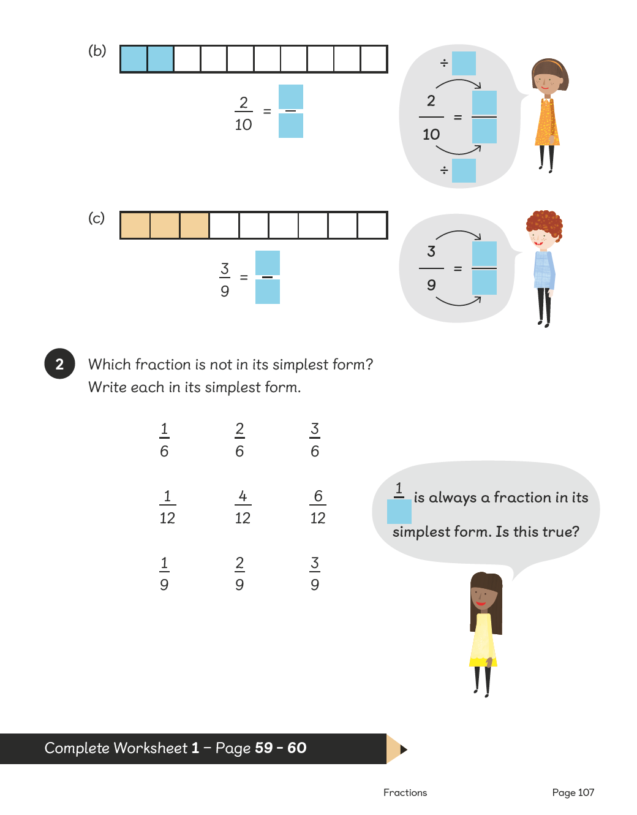

Section B



Section C

