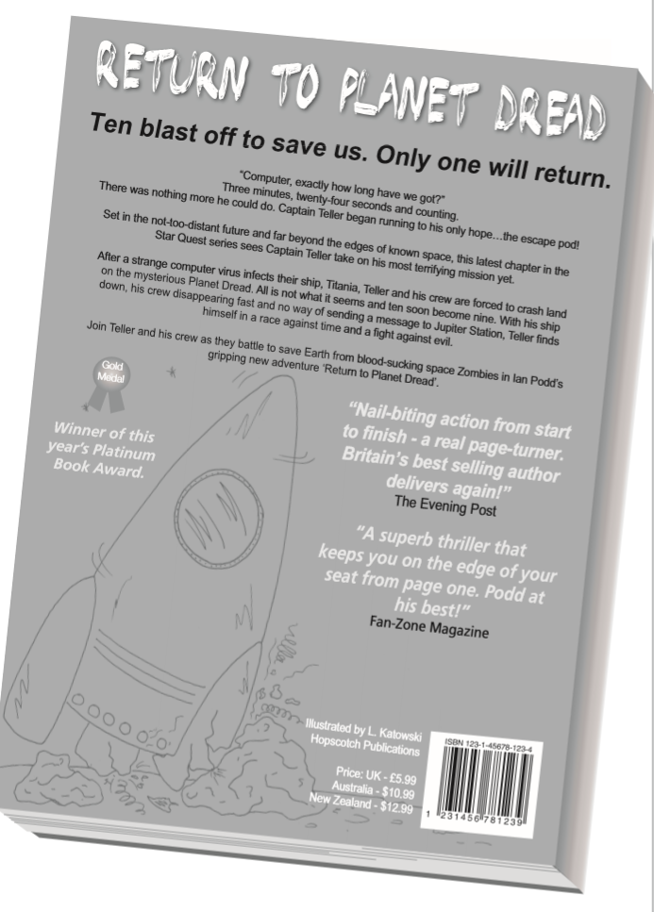Monday 16th November 2020

**Monday:**

1. Write a # to summarise the page:

#___________________________________

1. Below are some summaries of different paragraphs from this text.

Number them 1 – 4 to show the order in which they appear in the text.

The first one has been done for you.

|  |  |
| --- | --- |
| Teller and his crew are forced to crash land. |  |
| Three minutes, twenty-four seconds and counting. |  |
| Ten blast off to save us. Only one will return. |  |
| Teller finds himself in a race against time. |  |

1. Do you think this blurb is successful? Why?

____________________________________________________________________________________