16.11.20

LO: To round numbers to the nearest 10, 100 or 1000

Guided Practice

Round the following numbers to the nearest 10.

19 36 641
22 44 188
83 99 553

Round the following numbers to the nearest hundred.

219 333 8,401
342 454 1,902
743 9,709 5,833

Round the following numbers to the nearest thousand.

4,125 9,441

2,317 25,620

51,750 29,998

Bronze Challenge – Fluency
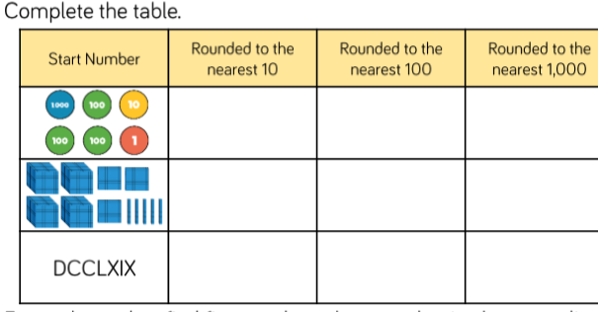

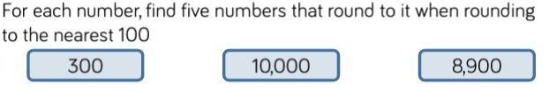

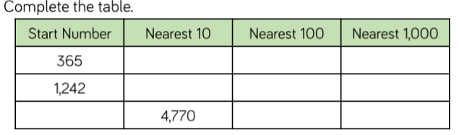

Silver Challenge – Reasoning

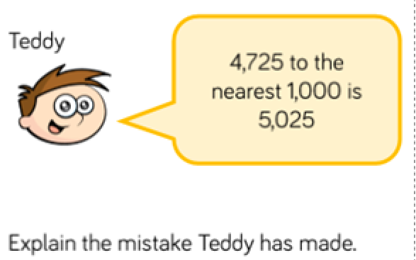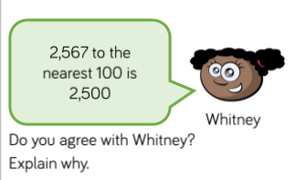

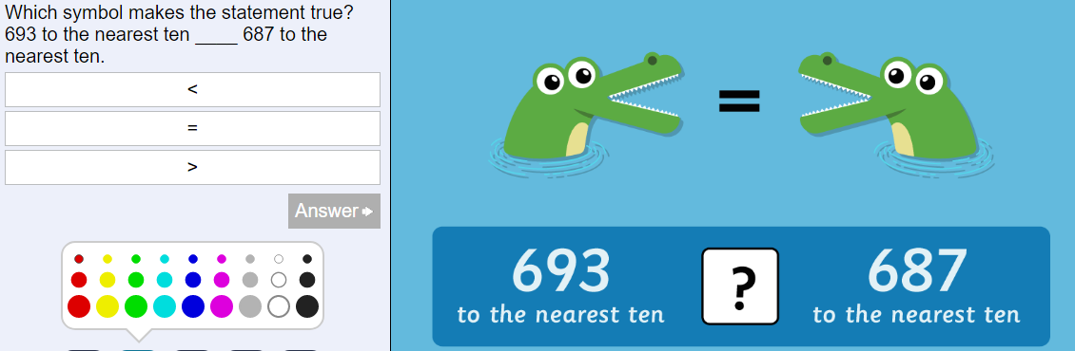

Gold Challenge – Problem Solving

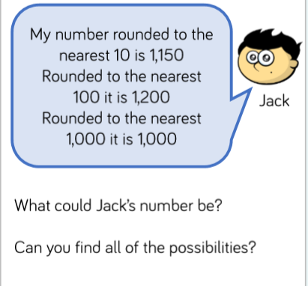

Challenge

A | B | C | D | E | F | G | H | I | J | K | L | M
400 | 450 | 55 | 510 | 0 | 550 | 22,000 | 900 | 10 | 2000 | 200 | 56 | 40

N | O | P | Q | R | S | T | U | V | W | X | Y | Z
940 | 100 | 3000 | 3300 | 6000 | 1400 | 1000 | 990 | 1320 | 520 | 1 | 4000 | 9999

Answer the following questions to crack my code.
The order of the letters in each word has been muddled up.

Question | Answer | Letter
387 is between 300 and _______.
1489 is between ________ and 1500.
980 is between 900 and _______.
32 is between 30 and _____.
863 is between 800 and ________.

Round 7 to the nearest 10
Round 1420 to the nearest 100

Round 3,522 to the nearest 1000
Round 35 to the nearest 10

Round 1318 to the nearest 10
Round 995 to the nearest 10
Round 12.6 to the nearest 10
Round 430 to the nearest 1000
Round 52 to the nearest 100
Round 554 to the nearest 10
Round 5,555 to the nearest 1000
Round 397 to the nearest 10
Round 994 to the nearest 10

Round 1970 to the nearest 100
Round 54.69 to the nearest whole number
Round 1429 to the nearest 1000
Round 45 to the nearest 100
Round 986 to the nearest 10
Round 452.9 to the nearest 10
Round 1363 to the nearest 100

The answer:
___ ___ ___ ___ ___ / ___ ___ / ___ ___ / ___ ___ ___ ___ ___ ___ ___ ___ ___ / ___ ___ ___ ___ ___ ___ ___ .

