Monday 16th November 2020

LO: To use ellipses, question marks and exclamation marks accurately

Add the correct punctuation into the phrases, sentences, and passages below. Most of them need question marks, exclamation marks, and ellipses.

1. “Who do you think you are talking to ” my mum asked.
2. “We’re going to Disneyland ” my sister screamed.
3. “He fell out of bed ” my mum blurted out laughing hysterically.
4. “Have you seen my new toy “ said Dean that’s wicked exclaimed Jake
5. “Do you brush your teeth regularly “ John enquired the dentist “no he most certainly does not “ butted in John’s mother.
6. “I was thinking “ he paused “perhaps we should go and get you that dog this weekend “ said Dad “really screamed Sophie that would be amazing “
7. Deborah asked “is the baby as big as it should be at this stage “ I’m quite certain that your baby is just fine “ replied the doctor.
8. “Tidy your room ” my dad shouted. I answered “yeah just give me a now “ he interrupted.

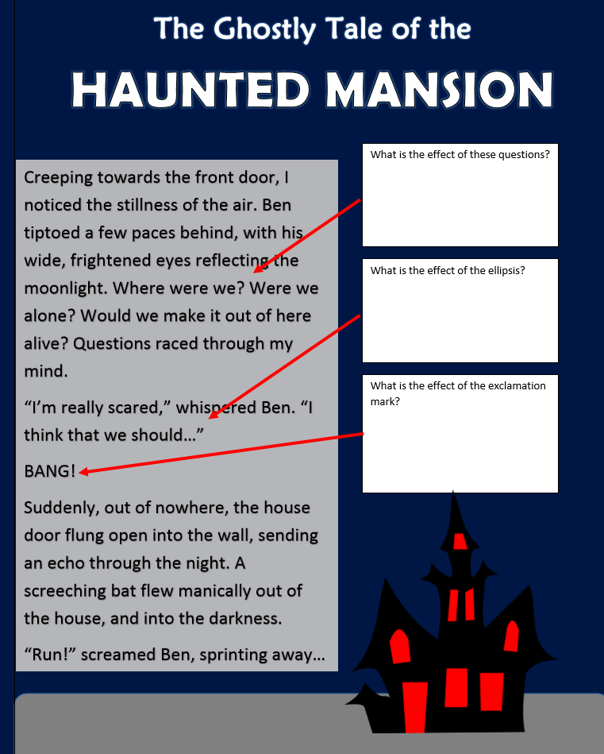

**You are now going to write your own haunted house descriptions! Use ellipses, question marks, and exclamation marks to create a spooky piece of creative writing.**

