Bronze Challenge – Fluency

- Order these numbers from the smallest to the largest:

334,111 21,142 12,466 234,321 53,232 542

2) Order these numbers from the largest to the smallest:

2,321 64,232 3,216 22,231 655,221 34 38,211

Compare these numbers using the symbols < >
- 4,322 __ 5,322
- 211 __ 4,210
- 32,242 __ 6,223
- 82,432 __ 34,223
- 111,111 __ 123,123
- 53,234 __ 3,123

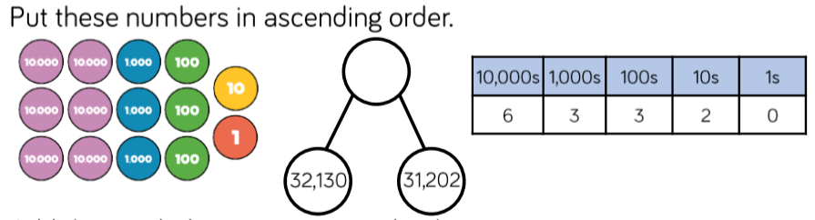

17.11.20
LO: To compare and order number up to 100,000

Silver Challenge – Reasoning

Adam says he has put the numbers in order form the smallest to the largest.
Can you explain what he has done wrong?

76 987 8,321 8,221 9,876 12,332

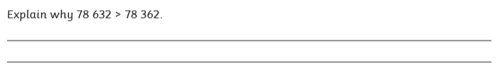

Gold Challenge – Problem Solving

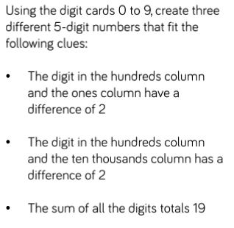

Challenge
Complete LBQ tasks

