18.11.20

LO: To count in powers of 10

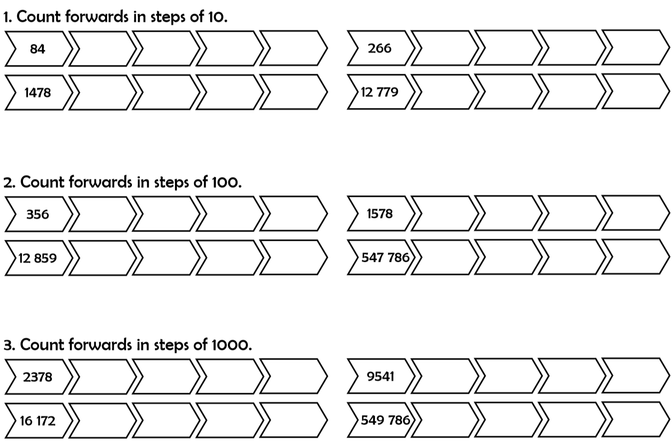**Guided Practice**

|  |
| --- |
| Bronze Challenge – Fluency |
|  |
|  |
|  |

|  |
| --- |
| Silver Challenge – Reasoning |
|  |
|  |

**Gold**

Complete LBQ task