WHAT’S WRONG

WITH THE PARENTHESIS?

Each of the sentences below use parenthesis incorrectly. Determine what is wrong and then write the sentence correctly.

1. Sam (the boy from school helped me with my homework.

What is wrong?

|  |
| --- |
|  |

Write the sentence correctly

|  |
| --- |
|  |

1. I am going to play with Rob (Who lives down the road from me)

What is wrong?

|  |
| --- |
|  |

Write the sentence correctly

|  |
| --- |
|  |

1. Jenny the girl from the yellow house invited me to her party.

What is wrong?

|  |
| --- |
|  |

Write the sentence correctly

|  |
| --- |
|  |

1. The dog – and the three cats – all ate their dinner peacefully.

What is wrong?

|  |
| --- |
|  |

Write the sentence correctly

|  |
| --- |
|  |

1. Nobody enjoys Mondays. (Not even me).

What is wrong?

|  |
| --- |
|  |

Write the sentence correctly

|  |
| --- |
|  |

ANALYSING PARENTHESIS

‘HOME’

Version A

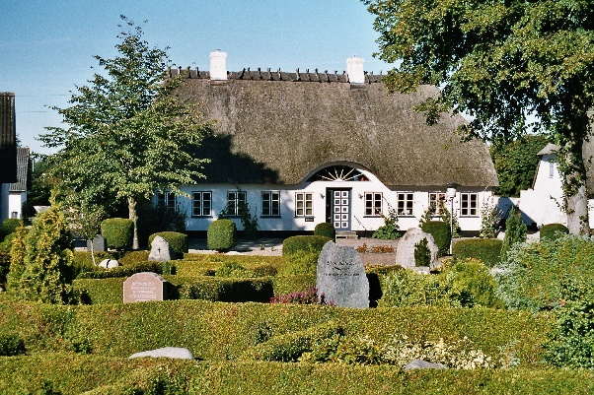My home is far more than just the place where I live. My home is a place where there are thousands of memories. It is also a place where people have come together. Whenever I go home I feel a sense of belonging. Wherever I go in the world a part of me will always be at home. I love my home.

Version B

My home, a cosy cottage in the North Yorkshire moors, is far more than just the place where I live. My home, with its large wooden beams and welcoming fireplace, is a place where there are thousands of memories. It is also a place where people have come together (such as the many joyous Christmases and birthdays). Whenever I go home - and I see the straw roof for the first time appearing over the rolling hills - I feel a sense of belonging. Wherever I go in the world (and I have been to many, many places) a part of me will always be at home. I love my home (and everyone in it).

Questions

1. What additional details are we given about the physical details of the house in Version B?
2. What additional details are we given about the feelings the writer feels about the house in Version B?
3. What is the effect of the use of parenthesis in Version B?
4. How could Version B be improved even further?

Now write out version A again below, but this time using your own accurate parenthesis to affect the clarity and meaning of the writing.

By the end, your writing should paint a clearer image of your home.

-Add in details about your own home

- Keep as many words from the original as possible, adding in parenthesis to make the writing more clear and precise.

