24.11.20

LO: To subtract numbers with more than 4 digits

**Guided Practice**

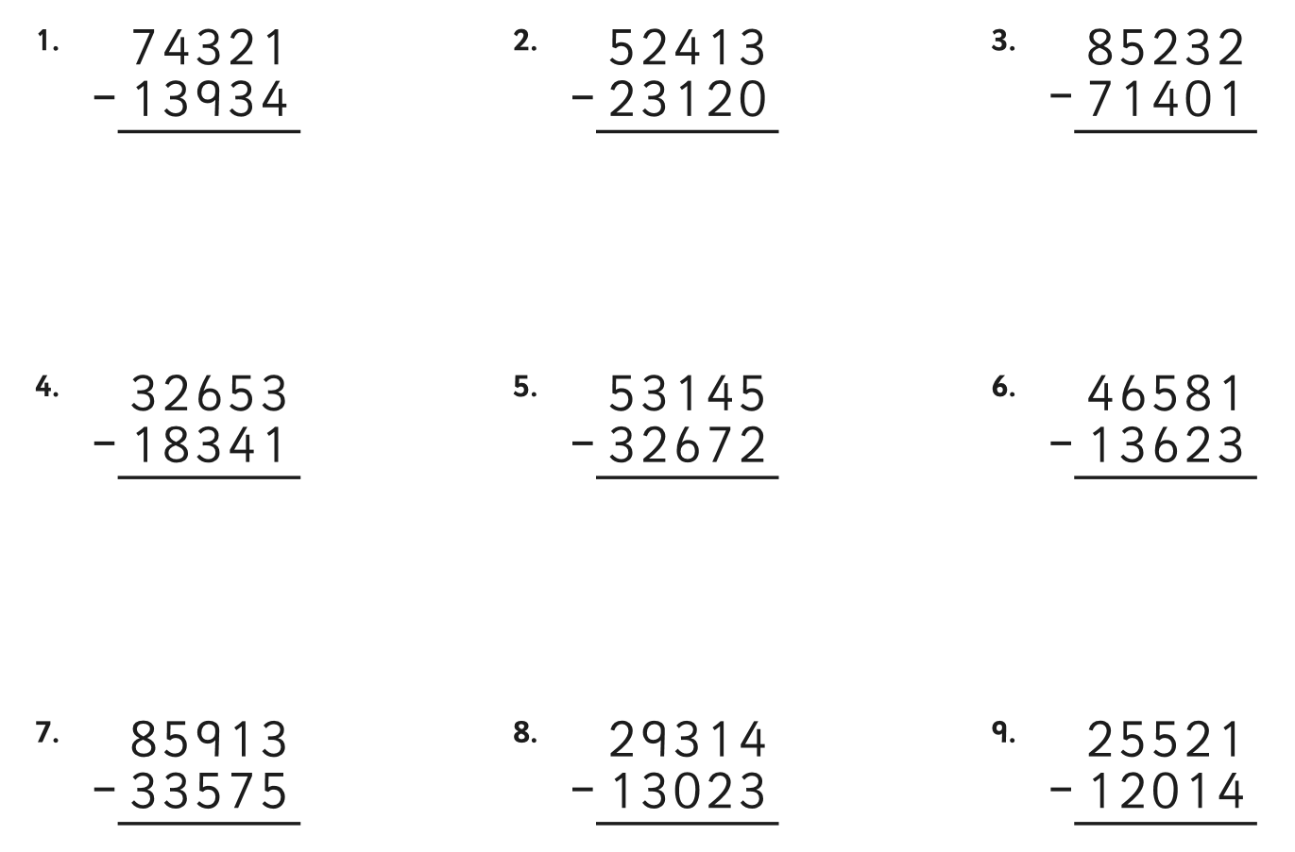

|  |
| --- |
| Bronze Challenge – Fluency |
|  |
|  |
|  |

|  |
| --- |
| Silver Challenge – Reasoning |
|  |
|  |

|  |
| --- |
| Gold Challenge – Problem Solving |
|  |

**Challenge**

Complete LBQ tasks