25.11.20

LO: To calculate inverse operations

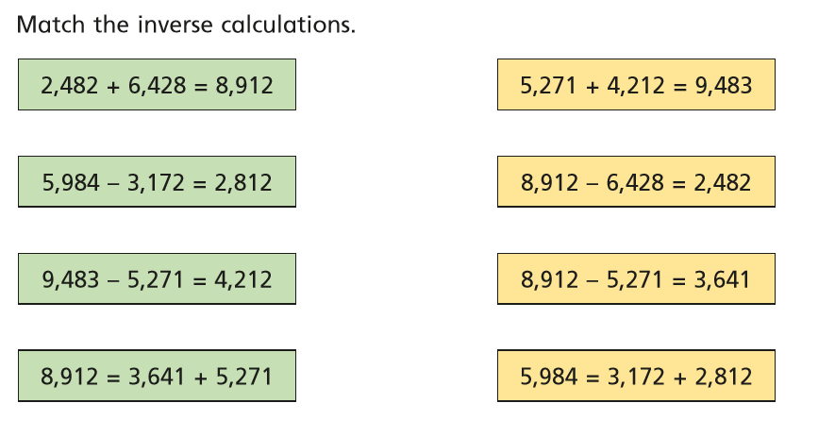**Guided Practice**

|  |
| --- |
| Bronze Challenge – Fluency |
|  |
|  |
|  |

|  |
| --- |
| Silver Challenge – Reasoning |
|  |
| Tommy checks his calculation using the same addition.  Is this a good idea? What calculation should he do?  Correct Tommy’s answer. |

|  |
| --- |
| Gold Challenge – Problem Solving |
| In total they have 8,524 marbles between them.  How many does Eva have? |

**Challenge**

Complete LBQ tasks