**PE Lesson**

This circuit training session can be completed each day. If you want to make it easier, only do five of each activity. If you want to make it harder, do five more of each activity. I have started with a 5-minute humorous warm-up video that you can do with other members of your family! Let’s get it on!

Warm-up: <https://www.youtube.com/watch?v=ldAA5_3AB8I&feature=youtu.be>

Activity 1: press-ups x 10

Activity 2: sit-ups x 10

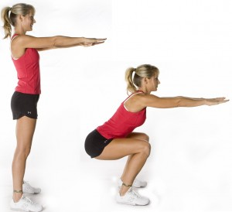Activity 3: squats x 10

Activity 4: squat thrusts x 30

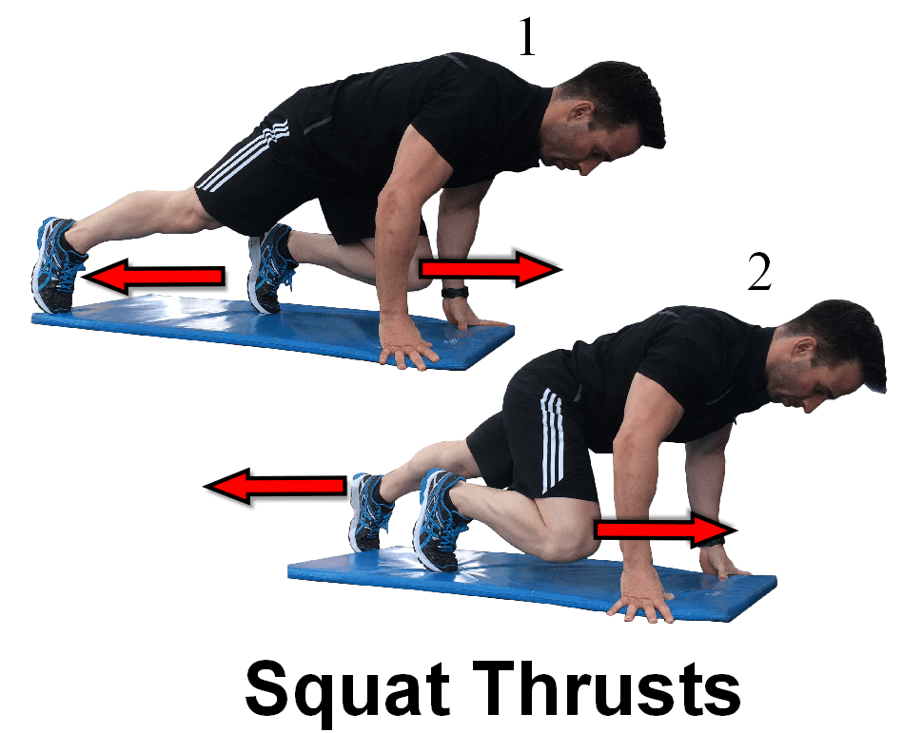

Activity 5: burpees x 30

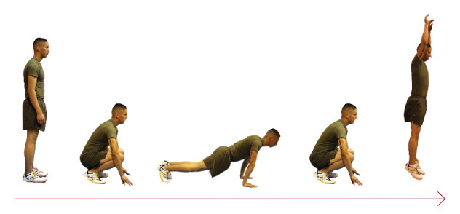

Activity 6: star jumps x 30

Activity 7: your favourite dance/Tik Tok video. One of my favourites is the Cha Cha Slide: <https://www.youtube.com/watch?v=wZv62ShoStY&feature=youtu.be>

Cool-down: <https://www.youtube.com/watch?v=7gMuN6m1Gso&feature=youtu.be>