  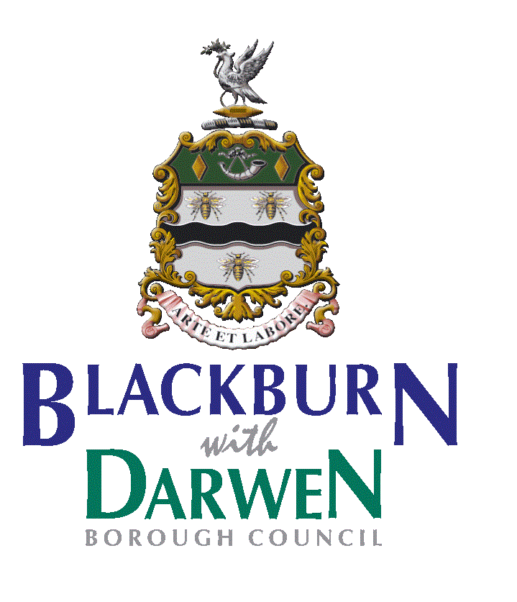

**WOODWIND WOPPS**

**It’s lesson 3 already – time flies by so quickly**

What have we learned about so far? The instruments of the woodwind family and the string family, and how they work together. We have also seen how the TEMPO and PITCH change in the music we play and listen to. Today we are looking at the brass family…

Watch this video of some of our brass students playing together!

(episode 3 part 2 - Bolton Symphonic Brass)

<https://youtube.com/playlist?list=PLfOAp79EQ5QuzQu_AayaC9u1cYvvZxAdz>

There are four main brass instruments the **Tuba**, **Trumpet**, **French** **horn** and **Trombone.** If you stretch out the pipes of each brass instrument, they are extremely long: a tuba can be over 5 metres in length – wow! Think about lesson 1 and PITCH. Remember, the bigger the instrument, the lower the pitch!

Can you put the tuba, trumpet, trombone, and French horn in order of pitch:

(lowest pitch)

1.

2.

3.

4.

(highest pitch)

**Activity…**

This week we are going to be focussing on **Dynamics**!

Dynamics is the word in music that we use to describe the *volume* of the music. We use different words to describe the dynamics in music:

**piano = soft/quiet**

**forte = loud**

**Listen to “Mars” from the Planets Suite by Gustav Holst**

<https://bbc.co.uk/programmes/articles/14ZjT5yjnKQRdKVsqrLzk1x/mars-from-the-planet-by-gustav-holst>

This piece is very dramatic. It uses the brass instruments a lot and has very loud dynamics!

Can you describe what happens to the dynamics in this piece of music?

In ‘Mars’, the music starts………………………………………………….and then………………………………………………………………………………………………………………………………………………………………………………………………..

**Time to get clapping/tapping…**

Listen again and see if you can clap/tap along to the main ostinato that runs throughout this music. Watch this video as an example of how to do this…

( Episode 3 – part 1 )

<https://youtube.com/playlist?list=PLfOAp79EQ5QuzQu_AayaC9u1cYvvZxAdz>

**Listening for the week…**

Watch this video of a very famous piece of music written for the French horn…

[**https://www.bbc.co.uk/programmes/articles/3H1v7vC6mqlnq715SS7s52Q/horn-concerto-no-4-by-mozart**](https://www.bbc.co.uk/programmes/articles/3H1v7vC6mqlnq715SS7s52Q/horn-concerto-no-4-by-mozart)

**We look forward to seeing the work you have done this week:**

**Miss Blackford, Mrs Kay, Miss Curwen, Mr McKend**