  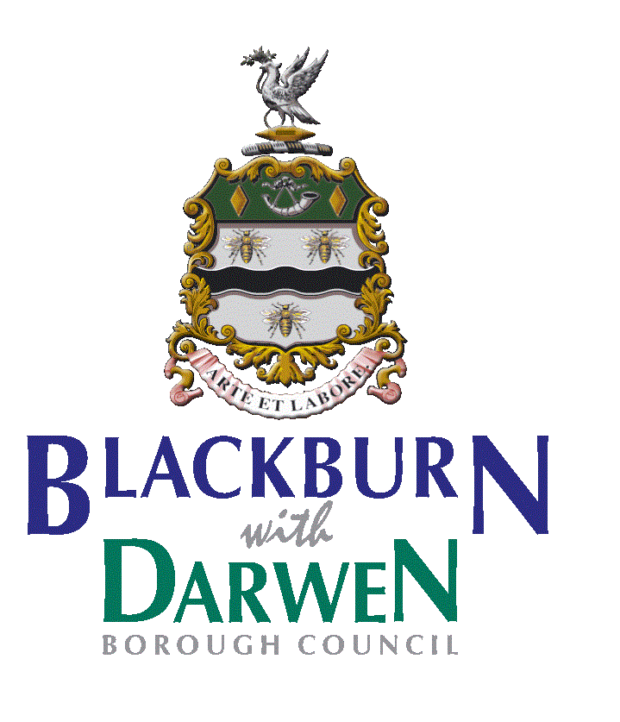

**WOODWIND WOPPS**

**Music challenge week…**

So far we have learned about the different families of the orchestra, how you play the instruments and how they work together. We have also learned how the tempo, dynamics and pitch change in a piece of music. You are all extremely good at music, but just to make sure you have not forgotten anything, we have created some challenges this week to keep your memories working hard. Good luck!

**Challenge 1 (how…?)**

Name the 3 ways you can play a string instrument…

………………………………………………………………………………………………………

Name the 3 ways you can play a percussion instrument…

………………………………………………………………………………………………………

How do you play the woodwind and brass instruments?

………………………………………………………………………………………………………

**Challenge 2 (which…?)**

How many instruments can you name in these families? If you reach the number in the bracket, that is superb!

The Woodwind (5)

The Strings (4)

The Brass (4)

The Percussion (4)

**Puzzle:** Just like it’s hard to say whether a tomato is a fruit or a vegetable, some instruments are really hard to put into families, because it’s not obvious how you play them or how they make a sound. Can you find which instrument family these funky instruments belong to?

|  |  |  |
| --- | --- | --- |
| *Instrument* | How it makes a sound | Belongs to which  family? |
| The organ |  |  |
| The mouthorgan |  |  |
| The bagpipes |  |  |
| The piano |  |  |
| The saxophone |  |  |

**Fun Listening Challenge:**

Listen to the Waltz of the Flowers, you’ll probably recognise it.

[**https://www.bbc.co.uk/teach/ten-pieces/KS2-tchaikovsky-the-nut-cracker-waltz-of-the-flowers-russian-dance/z4y3rwx**](https://www.bbc.co.uk/teach/ten-pieces/KS2-tchaikovsky-the-nut-cracker-waltz-of-the-flowers-russian-dance/z4y3rwx)

Which instruments can you see?

Describe the tempo and dynamics in the music?

**Very well done this term!**

**Miss Blackford, Mrs Kay, Miss Curwen, Mr McKend**